**ASSIGNMENT 10.6:**

1.)Write a pig script to find the minimum temperature observed in a given weather station in a particular year :

Pig Script:

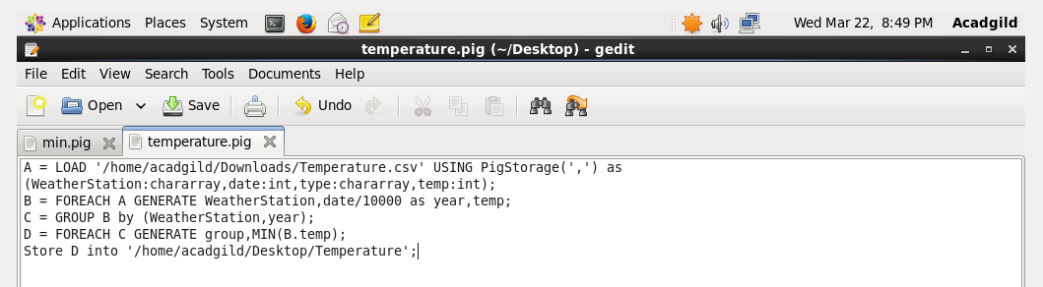

Output:

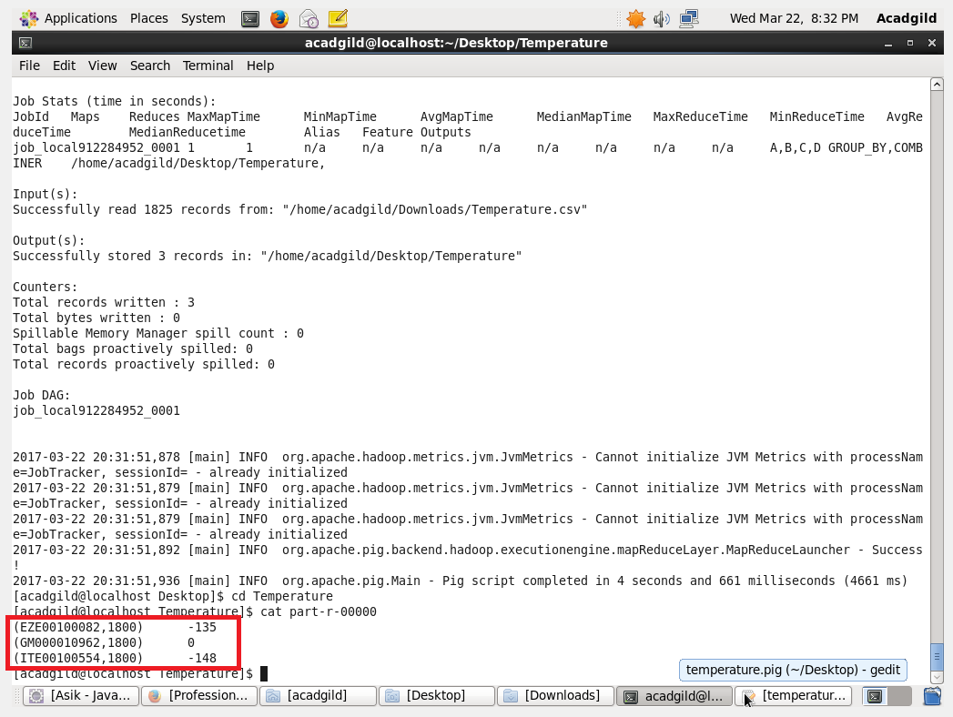

2. Write a pig script to find the maximum temperature observed in a given weather station in a particular year :

Pig Script:

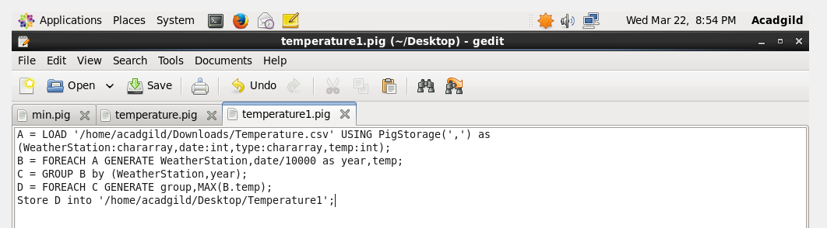

Output:

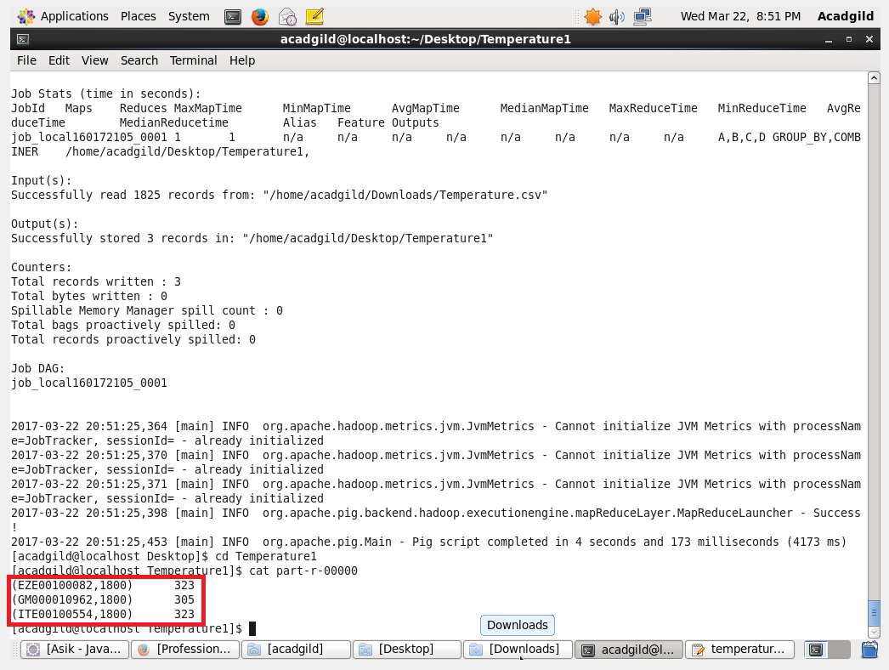

3. Write a pig script to find the number of readings given by each weather station according to the dataset :

Pig Script:

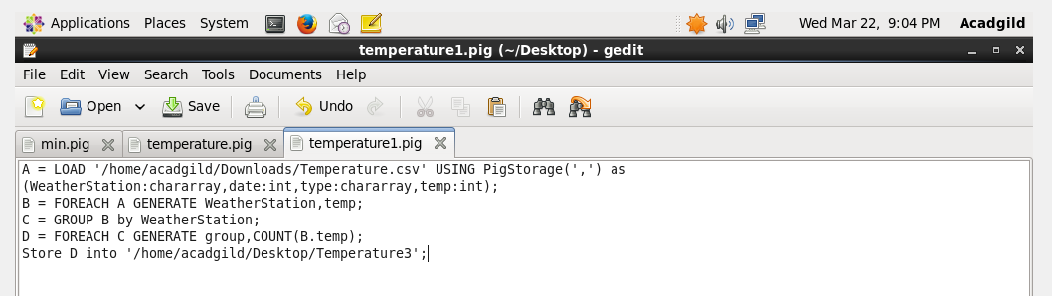

Output:

